ANNUAL SCUPPERNONG RIVER FESTIVAL
SATURDAY, OCTOBER 14, 2023
COLUMBIA, NORTH CAROLINA

REGISTER TODAY to participate in one of Northeastern North Carolina’s largest and most vibrant Fall Festivals. Attendance is expected to be 10,000. Make your plans EARLY; booth spaces will be assigned first-come, first-served.

COMPLETE THE FORM ON THE NEXT PAGE (PLEASE BE AS SPECIFIC AS POSSIBLE!)
AND RETURN THE FORM AND YOUR PAYMENT FOR BOOTH SPACE OR SPACES

Return to: Scuppernong River Festival, ATTN: Howard Phillips For more information contact:
PO Box 449 Howard Phillips at 252/796-7842 or
Columbia, NC 27925 David Clegg at 252/796-1371

CRAFT/NON-FOOD VENDOR BOOTH SPACES (MAIN STREET) ARE 10 ft. x 10 ft.
This year, the spaces will be on the south side of Main Street.

FOOD VENDOR BOOTH SPACES (BROAD STREET) ARE 12 ft. X 12 ft.
ATTN Food Vendors: you may need a Temporary Food Establishment (TFE) permit from the health department;
see “Information for organizers and vendors at fairs, carnivals, public exhibitions, or similar gatherings” below.

Cost for one booth space is:
- Craft/Non-food: $ 55.00
- Food: $165.00
- For after 5:00 PM sales there is an additional $25.00 fee which must be sent with your application. This is a per vendor fee, so it’s only $25.00 regardless of how many booth spaces you reserve.

Make Sure You Reserve Enough Space!
- All of your supplies and equipment MUST fit within the space, or adjacent multiple spaces, you reserve (spaces are 10’x10’ or 12’x12”; see above). This includes the tongue, tires, and all other parts of a trailer if used.
- If your trailer or other equipment requires more space than reserved, you will be charged for additional booth space(s) and you will likely have to move to wherever adequate space is available.
- If setting up a trailer, you are encouraged to arrive early; you must be able to maneuver the trailer into your space on your own – even if other vendors are already set up on either side of your space(s).

Make checks payable to: Scuppernong River Festival
- No Reservations will be accepted without full payment! NO REFUNDS!
- We must receive your application and payment by September 29, 2023 or you will have to pay a late registration fee. The late registration fee is $50.00. NO applications for space will be accepted on the day of the festival.
- Booth assignment(s) will be sent to you by October 3rd, 2023.
- IF YOU HAVE NOT RECEIVED YOUR BOOTH ASSIGNMENT BY OCTOBER 10th, PLEASE CALL Howard Phillips at 252-796-7842 BETWEEN 9 AM AND 4 PM, WEEKDAYS.

Please Note:
- You may NOT offer for sale any ammo, stink bombs, knives, bow & arrow, blow guns, weapons or other dangerous devices of any kind, canned string, or fake cigarette items. The festival committee reserves the right to prohibit the display/sale of any items it deems to be not in keeping with the family-friendly nature of the event; you must comply with any request by the committee to stop displaying such item(s).
- Vendors are responsible for any spills and cleanup of those spills. If you use grease for cooking - take it home with you; DO NOT pour it on grass or under shrubs.
- Vehicles will not be allowed to enter the festival area for set up after 8:30 AM. We will NOT give refunds due to late arrival or any other circumstances.
- Booth Spaces will NOT be sold on the day of the festival to new/unregistered vendors.
- We are NOT able to provide tables, chairs, water, electricity, etc. Bring anything you need to operate.
- The Town of Columbia, Tyrrell County and the Scuppernong River Festival assumes no responsibility for damage to persons or property during the event.
- Any sales tax liability incurred during the festival is the responsibility of the vendor.

ANNUAL SCUPPERNONG RIVER FESTIVAL
SATURDAY, OCTOBER 8, 2022
COLUMBIA, NORTH CAROLINA

VENDOR APPLICATION FORM
Please Write Legibly!! Or Use the Optional Electronic Form!

Name of Business, Group, or Individual: ______________________________________________________

Contact Person: ___________________________________________________________________________

Email Address: ____________________________________ Phone #: ( )_____________________

Full Mailing Address: ______________________________________________________________________
### street, city, state, zip

Type and Number of Booth Spaces Requested

Number of 12’x12’ Food Spaces (Broad St.): _______ multiply by $165 each = $_________________

Number of 10’x10’ Non-Food Spaces (Main St.): _______ multiply by $55 each = $_________________

Will you be staying after 5:00 PM? If yes, enter $25 additional fee: $_________________

Will your application be received by us after 9/29/23? If yes, enter $50 late fee: $_________________

Total Amount Enclosed (add all lines above): $_________________

Description of what you will be selling/providing (please be specific): ______________________________

__________________________________________________________________________________________

__________________________________________________________________________________________
Continue on back of this page if more space is needed.

Additional Information

Are you using a tent (Y or N)? _____ How many: __________ Tent size(s): ___________________

Using a trailer/van (Y or N)? _____ Set up size: __________________ (incl. tongue, doors, ramp, etc.)

Food Vendors, if using a trailer/van/etc., from which side do you serve: Driver / Passenger / Either (circle)

Signature: _________________________________________ Date: ____________________

Please mail this completed form with your check or money order
and Vendor Terms of Participation Agreement to:
Scuppernong River Festival – ATTN: Howard Phillips
PO Box 449
Columbia, NC 27925

Vendor Terms of Participation Agreement
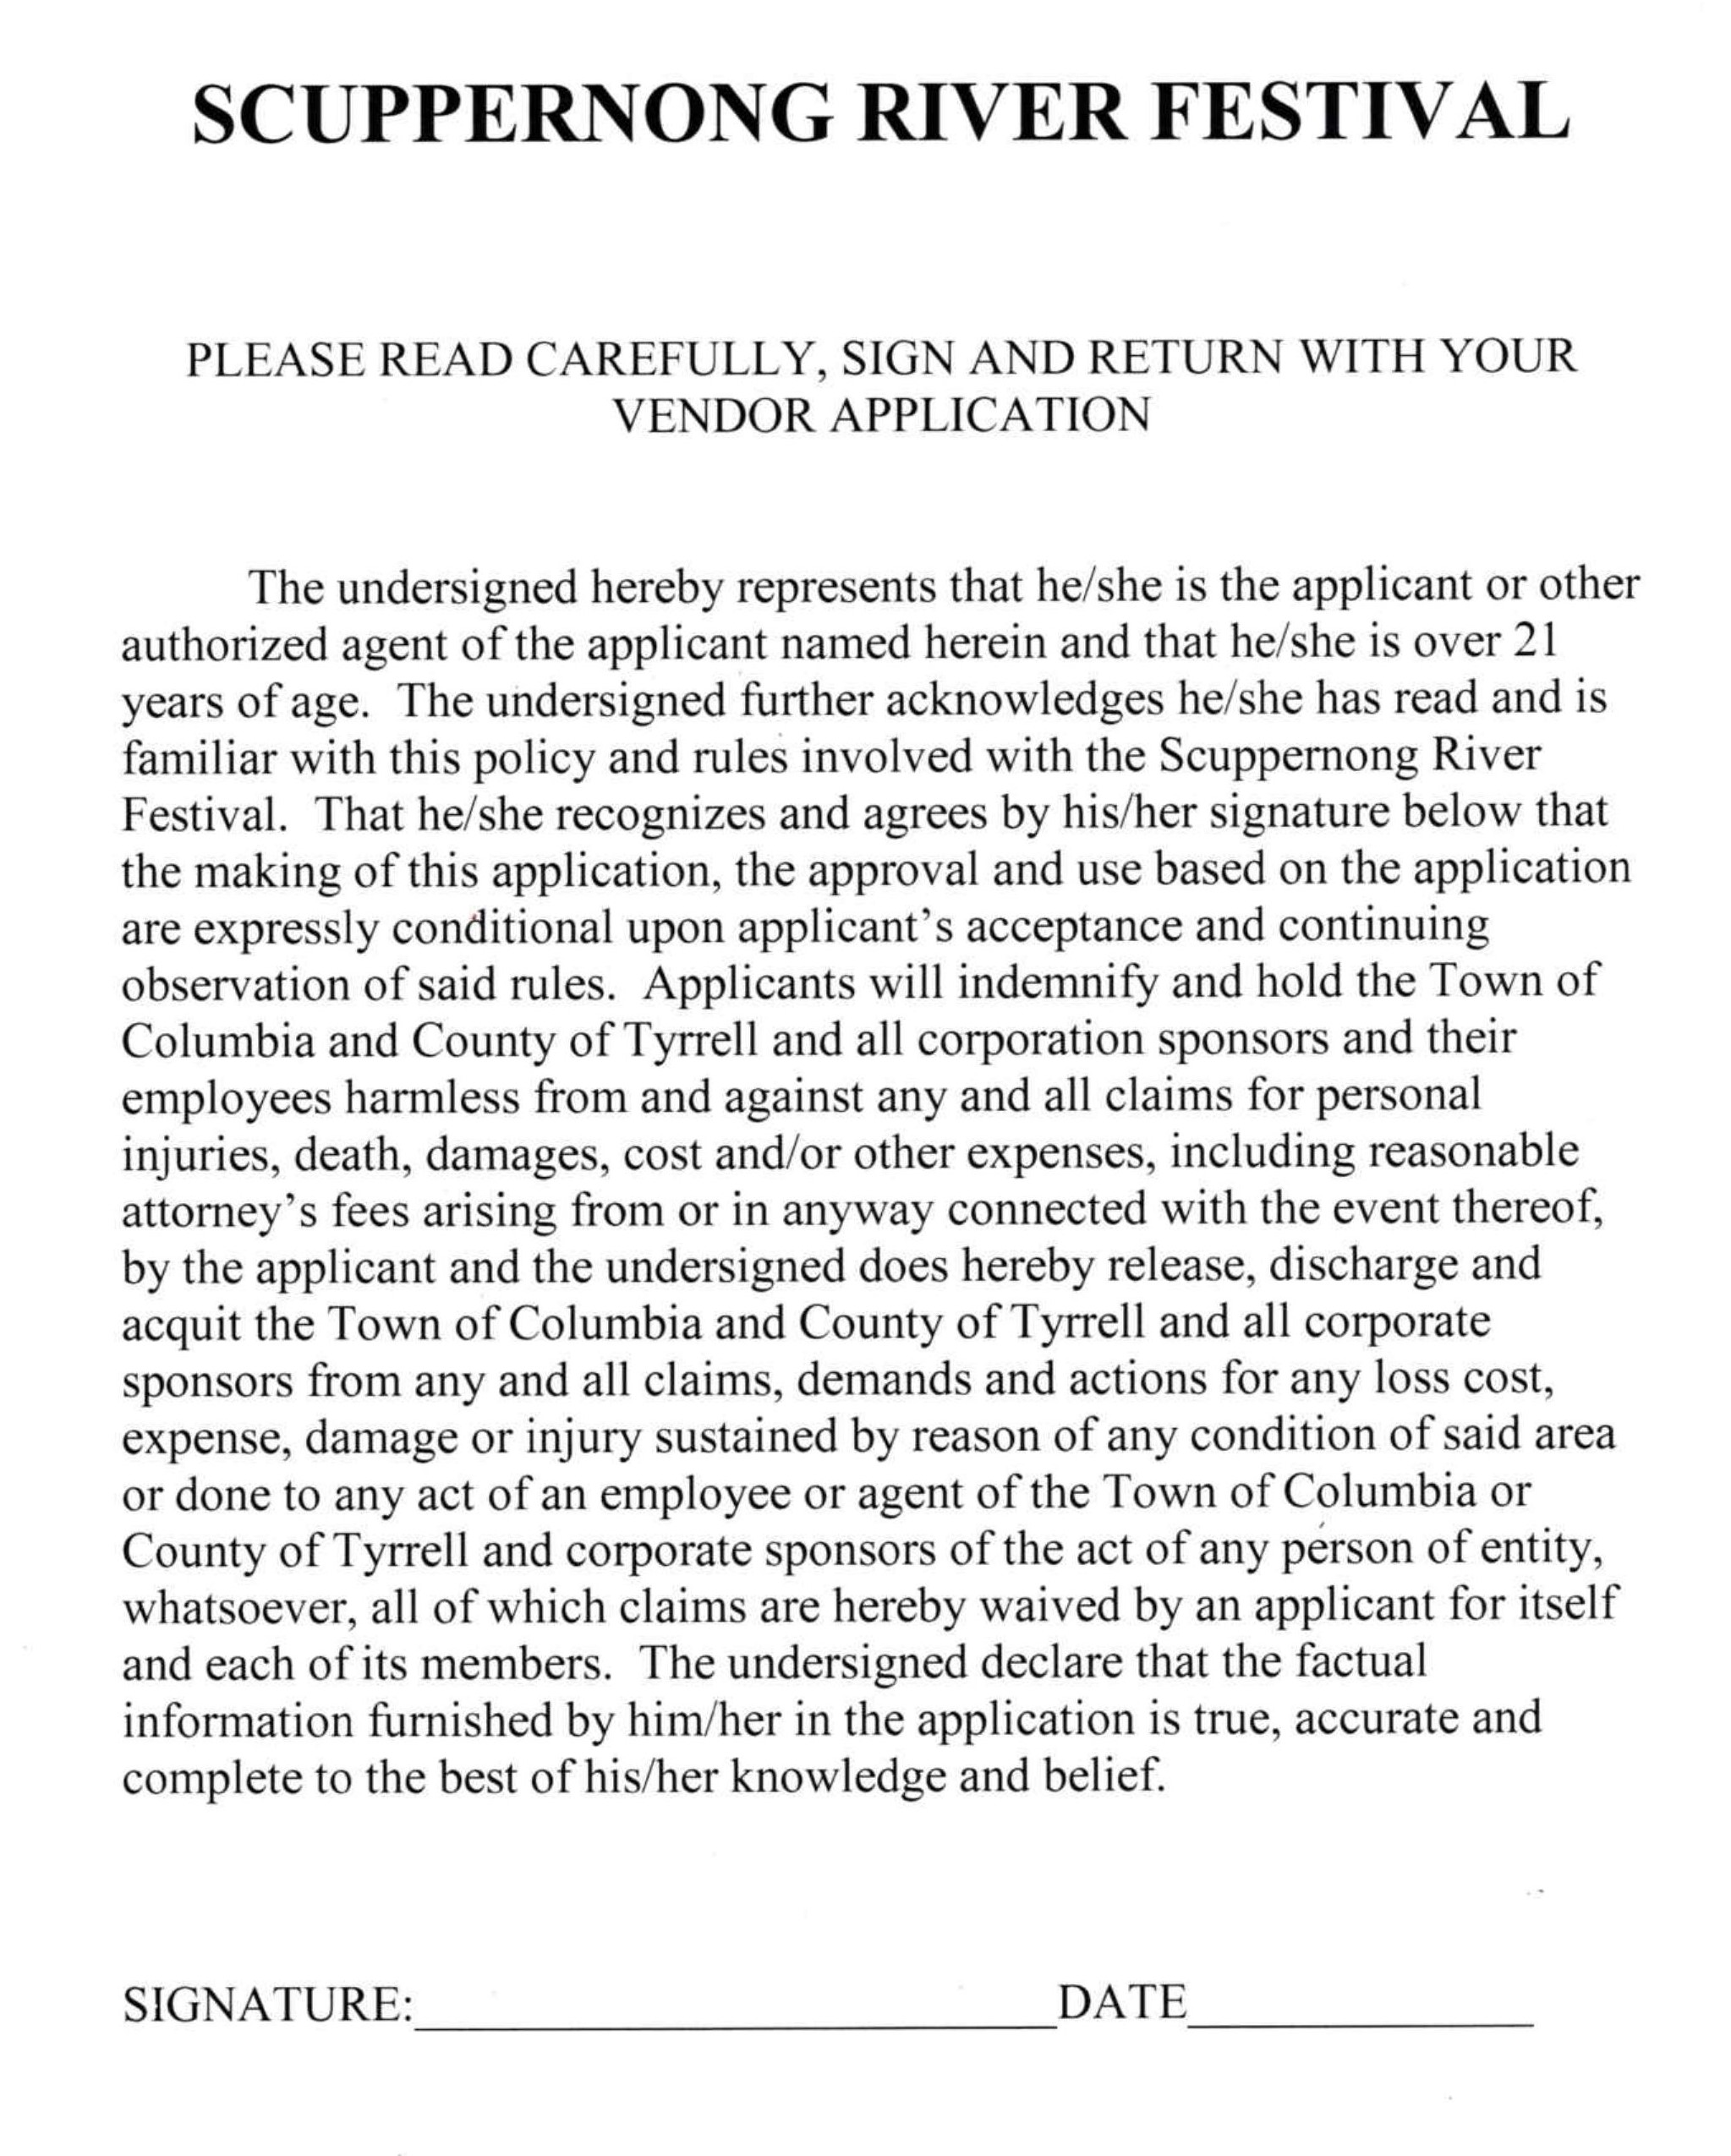

Vendor Information
Entry & Exit Routes (see map)
- All vendors must enter the festival area from the east end of Main Street, via Road Street, unless you are a food vendor arriving after 8:30 AM (see “Food Vendor Late Arrivals” below). All other entry points, including the intersection of Broad Street and US Highway 64, will be blocked.
- You can remove vehicles from the festival area via Broad Steet or Water Street ONLY.
- Food vendors serving from trailers or vehicles should note that odd numbered spaces are on the east (courthouse) side of Broad Street and even numbered spaces are on the west side. Depending on which side you serve from, and which side of the street your booth space is on, you may have to go down to the south end of Board Street and turn around.
Set Up
- All of your supplies and equipment MUST fit within the space (10’x10’ or 12’x12”) or spaces you reserved/purchased.
  - If a trailer is used, this includes the total set-up size of trailer including tongue, tires, ramp, any open doors, etc.
  - On the day of the festival, if your trailer or other equipment requires more space than you reserved, you will be charged for additional booth space(s) and you will likely have to move to wherever adequate space is available.
  - If setting up a trailer, you are encouraged to arrive early; you must be able to maneuver the trailer into your space on your own – even if other vendors are already set up on either side of your space(s).
- Vendors with cooking equipment must have a fire extinguisher.
- Food vendor health inspections are required and will be performed the day of the festival.
- Vendors must bring their own tables, chairs, etc. The festival does NOT provide electricity, water, sewer, etc.
- Vendor setup is between 5:00 AM and 9:00 AM. All vehicles, except those set up for sales within a vendor’s booth space(s), must be out of the festival area NO LATER THAN 9:00 AM (foot traffic on the streets usually begins to build up at that time and the parade along Main Street starts at 10:00 AM). No vehicles will be permitted to enter the festival area after 8:30 AM with the possible exception of the extreme southern end Broad Street (see Food Vendor Late Arrivals information below).
- Food Vendor Late Arrivals. Food vendors that arrive after 8:30 AM MIGHT be allowed to set up in the southern end of Broad Street (near US Highway 64) IF adequate space is available. WE CANNOT GUARENTEE YOU WILL BE ALLOWED TO SET UP IF YOU ARRIVE AFTER 8:30 AM.
  - If allowed, late food vendor arrival entry will only be possible from US Highway 64. You MUST receive approval & space assignment from event staff working the food vendor area PRIOR to setting up if arriving after 8:30 AM.
  - If you are a food vendor and you cannot arrive by 8:30 AM, call me at 252-796-7842 and tell me when you expect to arrive. The longer your arrival time is past 8:30, the less likely we will be able to accommodate you. If your actual arrival time is past 9:30, entry will almost certainly be denied. If we allow entry after 8:30, you will be assigned a space on the south end of Broad Street (probably well away from the other vendors) and you must remove any vehicles not within your booth space from Broad Street by 10:00 AM (when the parade starts).
  - Law Enforcement Officers at the barricade (on Broad Street at the intersection with US Highway 64) will not allow you to enter without advanced notification from me or other event staff. You also need to understand that after 9:00 AM (and often even before then) there will be festival attendees walking all over Broad Street and you will have to be extremely careful operating your vehicle to avoid injuring anyone.
Take Down
- Unless a vendor has paid to remain after 5:00 PM, all vendor materials and equipment must be removed from the festival area by that time.
Parking
- Following set up, vendors must find legal parking spaces for their vehicle(s) outside of the festival area.
- Parking is easier to find the earlier you arrive and complete set up.
- The DOT Rest Area overflow parking area, across US Highway 64 from the event area, is a good place to check.
- Some parking along town streets outside of the festival area is usually available.
  - Be advised that the parade route includes Bridge Street. Most of the streets in Columbia are narrow, including Bridge Street. There are usually many large vehicles in the parade that must be able to get down Bridge Street - so to keep your vehicle safe, you may want to avoid parking on Bridge Street.

From: https://mtwdistricthealth.org/environmental-health/
